Using Photospeak and Bitmoji to create a cloze listening activity in Learning Apps
Before you start:
You will need the following apps downloaded to your mobile or device:
- Bitmoji
- Photospeak
- YouTube (with your own YouTube channel/school channel).
You will also need to create a free LearningApps account.

- Use the Bitmoji app to create a character which looks like you.
- Choose a ‘sticker’ of your face from the app (fairly close up) and save directly to your camera roll.
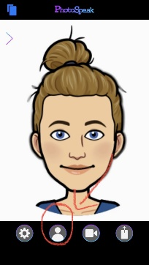
- Open PhotoSpeak. Use the ‘person’ icon at the bottom and choose the Bitmoji picture from your camera roll as your avatar.
- Allow the app to find the eyes and mouth of your character, which will be highlighted in green, and hit the tick in the top left hand corner of the screen if the markers are in the correct place.

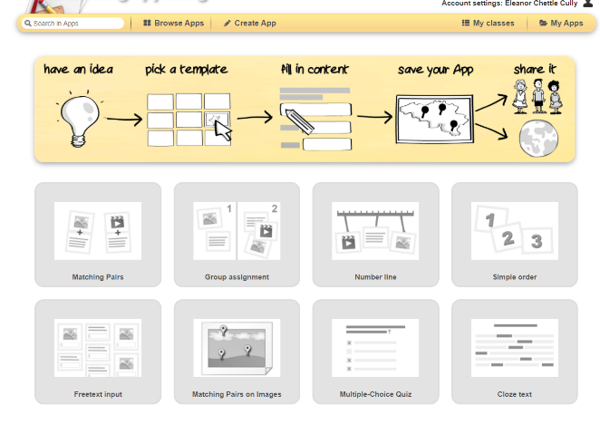
- Go to Learning Apps and select ‘create app’. Select the ‘Cloze Text’ option.
- Fill in the title and description of your text and use the ‘task type’ area to decide if you want children to choose vocabulary from a drop-down list or type it in themselves.
- Type the main body of your text into the ‘cloze text’ box, making sure that wherever you want a missing word you put -1-, -2-, -3-, etc. in sequence.
- Add the missing words into the ‘clozes’ section.
- Go back to PhotoSpeak. Click on the camera icon at the bottom of the screen and then on the red dot which will appear just above it, to record your text, including the missing words. Once you’ve finished recording, press on the square to end.
- Save your work and give it a title.
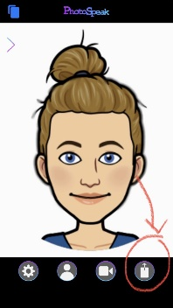
- Hit the ‘share’ icon at the bottom of the screen. Scroll down to ‘save video’ to save to your camera roll.
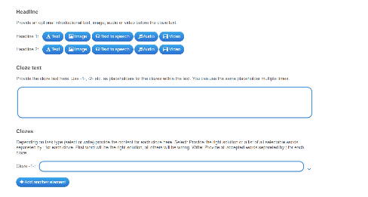
- Use the YouTube app to upload the video to your YouTube account.
- Go back to Learning Apps and click on ‘Headline’ section, selecting video.
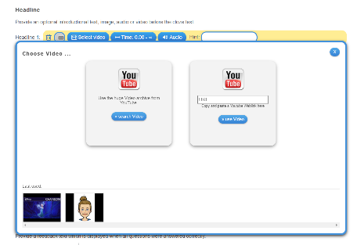
- Using the URL from your newly uploaded YouTube video, copy and paste into the right-hand box on your screen.
- You should now have a video of you speaking the text aloud above the text itself, with the capacity to pause/rewind etc.
- Save your Learning App and share the link with your pupils.
